ROLLL NUMBER : 21L-5654

NaME Muhammad Hamza Khan

Quiz 1

Q1:

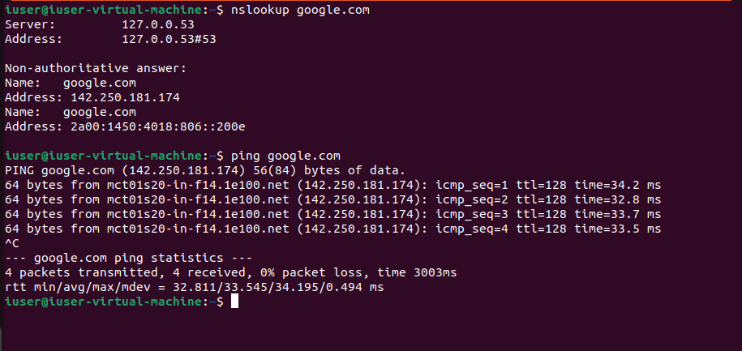

Q2:

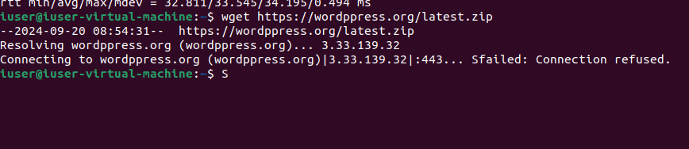

Q3:

1.

Frame 7 and 8 :

TCP segment length of 7 is 60 bytes

TCP segment length of 7 is 1484 bytes



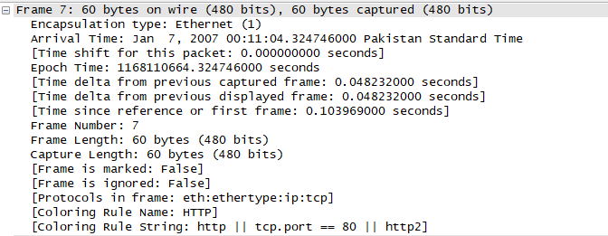

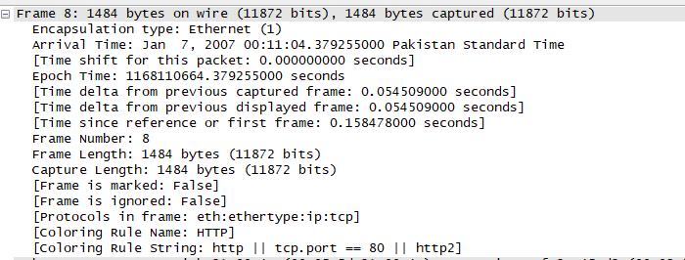

2.

Actual file request is 2575

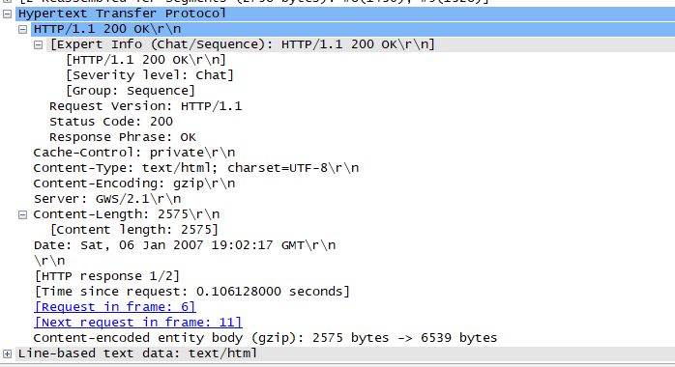

3. 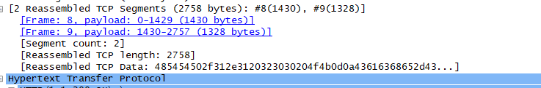

4.

